Web Programming

Laboratory Weekly Report

Week 3

**Project – Library Management System**

Aim: To design a functional library management system

Techniques Used: HTML, PHP

Procedure

1. addBook.php: This page is used to show the various details of the selected book like
   1. The link to download it
   2. The poster of the book
   3. The author’s name
   4. The video link to the book
   5. The link to the audio book

The details need to be added by the librarian and the page works in tandem with “db.php”

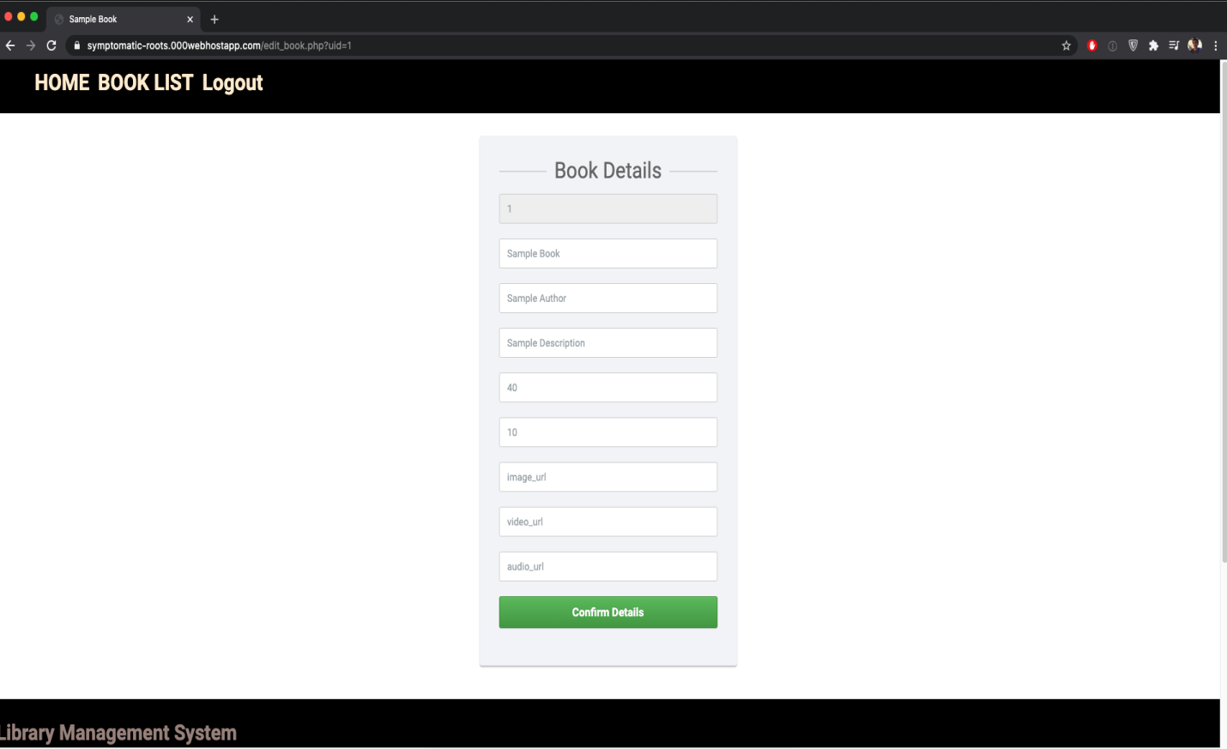

1. auth_session.php: A php module to authenticate the login of the users and the librarian. The code is:

|  |
| --- |
| <?php |
|  | session_start(); |
|  | if(!isset($_SESSION["username"])) { |
|  | header("Location: login.php"); |
|  | exit(); |
|  | } |
|  | ?> |

This works in tandem with “login.php”